Crafting Effective Resume Bullets | Beyond OSU: Artifact

Assignment Overview:
Bullet points add both depth and breadth to a resume. Your bullet points allow you to showcase your
responsibilities, skills and accomplishments. They allow you to paint a picture of what a job, internship, volunteer opportunity, student organization, etc. looked like for you.

Learning Outcomes:
- Identify the structure of a good bullet point.
- Construct effective bullet points using your skills and experiences.

Beyond OSU:
This assignment falls under the Beyond OSU I (Prepare) learning outcome #2: Apply life-long career development
concepts through the creation of career relevant artifacts.

NACE Competencies:
Skills developed completing this assignment: Professionalism, Communication, Critical Thinking, Career & Self-Development
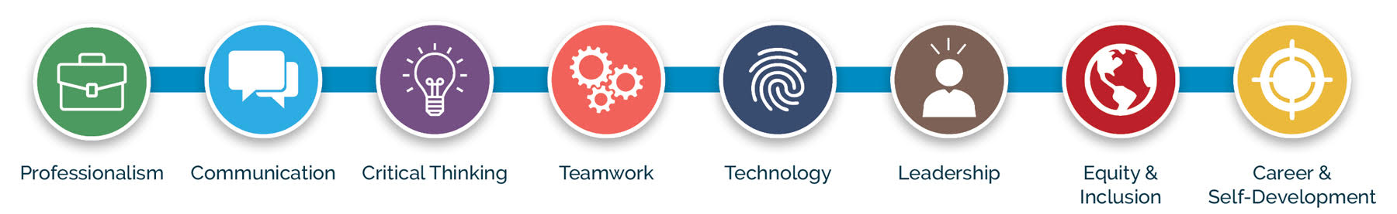

Student Instructions:

Step 1:
Examine the formula: (Action Verb) + (task/responsibility) + (how/why/results). Think about your
experiences:
- How were you able to accomplish your task?
- Did you use specific tools?
- Did you collaborate with others?
- Why did you perform this task?
- Why was it important in your role?
- What were the results (efficiency, improvement)?
- Can you quantify it? If so, use numbers to strengthen your outcomes.

Step 2:
Study examples:
Bullet Overview: Demonstrated excellent customer service.
Option 1: Provided a prompt greeting to customers and checked in to assist with any questions (how).
Option 2: Provided prompt and friendly greeting to customers, answered questions, and provided information on products and current sales to build relationships with customers and create a welcoming environment (how/why).
Bullet Overview: Made a documentary.
Option 1: Produced a 7-minute documentary on the traditional crafts of Western North Carolina for exhibit at the Mountain Heritage Center on preserving Appalachian craftsmanship (why).
Option 2: Collaborated with colleagues and experts to create a 7-minute documentary highlighting the history and messages of the Mountain Heritage Center exhibit on traditional crafts (how/why).

Step 3:
Think about similar things you did:
- Managed practice schedules and travel plans for 15 middle school swimmers while performing general administrative tasks.
- Mentored and trained a team of eight student workers in the admissions office, collectively leading 25 family tours a week.
- Grew our student email subscriber list from 50 to 300 in six months, resulting in a 50% increase in attendance rates.

Step 4:
Consider the length: It’s essential to add depth where it’s needed but keep a variety of lengths in your bullets.

If a task or skill used in completing a task isn’t highly relevant to the employer, keep it short. You don’t want to cause reader fatigue. Additionally, it’s important to demonstrate your understanding of what skills and experiences are most relevant to the position. It’s also okay not to include everything you did – if a task has no relevance and you have plenty of other experience, leave it off your resume. Keep transferable skills in mind. Maybe you won’t be stocking shelves in your next opportunity, but you might want to highlight your attention to detail, problem solving, taking initiative or creating a positive customer experience. Try the assignment on Transferable Skills!

Student Worksheet:

Part 1:
Give it a try (Action Verb) + (task/responsibility) + (how/why/results)
In the spaces below, write three initial bullet points (or take some from your resume) and write a different version of this same bullet thinking through the process. Consider the different skills you might highlight or try emphasizing how in one bullet and why in another. Add numbers where possible to add clarity and detail. How were you able to accomplish your task? Did you use specific tools? Did you collaborate with others? Why did you perform this task? Why was it important in your role or to the organization? What were the results? Did you increase something? Save money? Build relationships?

Bullet #1: Original Attempt
Add bullet in this space:

New Attempt
Add bullet here:

Bullet #2: Original Attempt
Add bullet in this space:

New Attempt
Add bullet here:

Bullet #3: Original Attempt
Add bullet in this space:

New Attempt
Add bullet here:

Part 2:
Share your bullets with peers in class (groups or one-on-one) or via a discussion board. Giving and receiving
feedback on bullets is an easier way to ask for help versus having someone look over your entire resume. Provide
a little insight into the position if it helps to clarify.

Add your peer feedback notes in the space below. What did you learn from having someone else read it?

Notes for Instructors:
Please adjust this assignment as needed to fit your schedule, point system and course outcomes. While this resume bullet assignment is designed intentionally to be short, we know that career development is not a one-size-fits-all process. Be mindful of your audience and their specific resume needs.

Suggestions for this assignment:

Length:
You can add a peer review to this assignment to produce more interaction and dialogue for students. Coach students through any industry expectations on how to best promote themselves in specific fields.

Assessment & Submission:
Please assess this assignment in line with other work for your course, and direct students in how you would like them submitted (printed and turned in during class, filled out electronically and submitted via Canvas, etc.). In terms of scaffolding, the Transferrable Skills Assignments is good pre-work or a peer review could be added after bullet creation.

Additional Resources:
Please consider using the robust online resources the Career Development Center offers you and your students. For more information on using the Career Development Center's tools, events and workshops in your classroom, please visit our website.

Designed and created by the:
Career Development Center
career@oregonstate.edu

