Creating Your Network Map | Beyond OSU: Artifact

Assignment Overview:
For this assignment, students will think through references, mentors, peers, former and current employers, teachers and social spheres to build a networking map. This assignment has an included framework but can be tailored by the instructor based on industry needs.

Learning Outcomes:
- Identify areas of personal networking related to career connections.
- Create actionable steps to build on identified networks.

Beyond OSU:
This assignment falls under the Beyond OSU I (Prepare) learning outcome #2: Apply life-long career
development concepts through the creation of career artifacts.

NACE Competencies:
Skills developed completing this assignment: Professionalism, Communication, Career & Self-Development
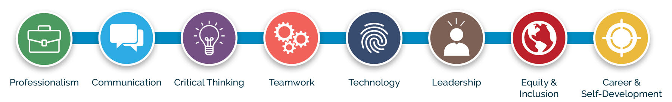

Student Worksheet:
For many students, networking is a foreign concept that can feel very invasive in asking for help from strangers or people they don’t know well. This assignment helps students identify connections close to them, then expands to create logical pathways for reaching out. Once you ask one person for help or advice, this process becomes easier. The point is to try to make more intentional connections in your career journey.

Step 1:
Identify: For each of the categories below, identify individuals who could be good career connectors.
Note: These don’t need to be people you know well but try to name at least one per category. (A good career connector has knowledge of career paths, skills/knowledge in a specific area, good contacts/networks and support for your personal career journey.)
Friends/Peers | Mentors | Professors and Advisors | Co-workers or Supervisors | Family/Other

Step 2:
Expand: At the top of each column below, pull down one of the names from the columns above.
Below them, list up to 3 ways that person could support your career (e.g. write recommendations, make introductions, provide insight, answer questions, help form clear goals, mentor on career planning, etc.).
Friends/Peers | Mentors | Professors and Advisors |  | Co-workers or Supervisors | Family/Other
1. | 1. |  | 1. | 1. | 1.
2. | 2. |  | 2. | 2. | 2.
3. | 3. |  | 3. | 3. | 3.
*Now that you have a list of at least five people, you have a starting point for informational interviews, general questions or setting up a time to meet and network for advice. Once you start, you’ll feel more comfortable talking to other people.

Optional Reflection:
Once you have your network map completed, reflect on the assignment and note some steps you would like to take in your future. In 300-400 words, answer the following question within your reflection.

What did you learn from this exercise? Are you comfortable reaching out to anyone on this list? Why or why not?
What steps seem appropriate for you to take following this assignment? What makes you excited about these
steps? What makes you nervous about reaching out to people? Use the remainder of this page to write your
reflection.

Notes for Instructors:

Please adjust this assignment as needed to fit your schedule, point system and course outcomes. While these are designed intentionally at this length, we know that career development is not a one-size-fits-all process. Please add specific industry networking elements to make this assignment more engaging where needed.

Suggestions for this assignment:

Length:
This assignment shouldn’t take students long to complete, and you can add more depth to any of the categories you feel necessary. You could also have students list an additional column for professionals who they aspire to connect with. There is an optional reflection paper on this worksheet to increase action items following this assignment. Coach students through any industry expectations on how to best reach people and the questions they might want to ask them.

Assessment & Submission:
Please assess this assignment in line with other work for your course, and direct students in how you would like the assignment turned in (printed out and turned in during class, filled in electronically and submitted via Canvas, etc.). In terms of scaffolding, a possible sequence is as follows: Personal Brand, Elevator Pitch, LinkedIn Profile, Network Map, LinkedIn Job Search, or you can choose from a few of these depending on your student’s needs.

Additional Resources:
Please consider using the robust online resources the Career Development Center offers you and your students. For more information on using the Career Development Center's tools, events and workshops in your classroom, please visit our website.

Designed and created by the:
Career Development Center
career@oregonstate.edu

