Creating your Elevator Pitch | Beyond OSU: Artifact

Assignment Overview:
An elevator pitch is a short and powerful summary of your experiences, skills and goals. It’s a 30-second conversation starter you use when networking with employers or grad schools or when attending events like career fairs. An elevator pitch can also give you a baseline to answer “tell me a little bit about yourself” questions in interviews.

Learning Outcomes:

- Identify the components of an elevator pitch.
- Apply your skills and experiences to formulate your own effective pitch or summary.

Beyond OSU:
This assignment falls under the Beyond OSU I (Prepare) learning outcome #2: Apply life-long career
development through the creation of career relevant artifacts.

NACE Competencies:
Skills developed completing this assignment: Professionalism, Communication, Career & Self-Development
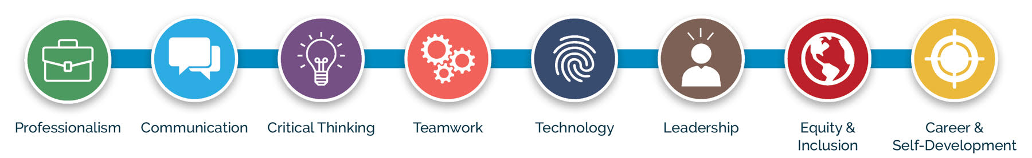

Components of the Elevator Pitch:

Step 1:
Who are you? Introduce yourself by sharing your name and explaining what school you attend, your academic
program or where you currently work.

Step 2:
What makes you stand out? Think of this as the unique blend of skills and experiences that make you different
from the other potential applicants (or your classmates). What is your most relevant quality, experience or skill? It
could be previous work, life experiences, projects, accomplishments, classes you have taken, software, field work,
volunteering, hobbies, etc.

Step 3:
What are your goals? This allows employers to understand what you are looking for: career information or advice,
an internship, a summer job, a part-time or full-time position. Before you go into a conversation, spend time
clearly defining what you want to gain from that interaction.

Sample Pitches:
“Hello, I’m Tai-Renée Moore. I will be receiving my bachelor’s degree in hospitality management from the OSU College of Business in June. I have interned at several hotels including the Hyatt Regency and the Holiday Inn. I also have sales experience as the fundraising chair of my sorority. I am currently seeking a sales position in the hotel industry.”

“Hello, my name is Raquel Saalfeld. I’m a senior at OSU majoring in natural resources. I spent last semester as an intern with the Washington Department of Natural Resources working on conservation outreach programs for youth. I have also been a camp counselor with an outdoor school for multiple summers. Through these experiences, I discovered a passion for working with young people and environmental education. I'm eager to use this background to drive positive social change within an organization.”

“Hi, my name is Freddy Dorres, and I am a student at OSU working on my bachelor’s in computer science. My coursework has equipped me with coding skills in languages like Java, C and Python. I also have experience in data analytics and visualization that I honed at an internship with Amazon last summer. I hope to find an internship with a tech company where I can utilize my ideas, coding skills and keep learning new things.”

Student Elevator Pitch Worksheet:

Tips:
Keep it short and sweet: Your elevator speech is a sales pitch. 30-60 seconds max!
Focus on the essentials: Say who you are, what you do and what you want to achieve.
Be positive and persuasive: Focus on what you want to do, not what you don’t want to do.
Practice, practice, practice: Deliver your speech to a friend or record it. Work at it!
Meet people: Get out into the world and talk to people. Put your ideas into action.

Part 1:
Who are you? Introduce yourself by sharing your name and explaining what school you attend, your
academic program and/or where you currently work. Give it a try in this space below.

Part 2:
What makes you stand out? What qualities are you most proud of or what makes you unique? Make sure to
mention qualities you possess that you feel are important. This is also a time to state relevant accomplishments.
Use this space below to make a list.

Part 3:
What are your goals? This lets employers know what you are looking for: an internship, summer job, part-time or full-time position, etc. Use the space below to list your goals.

Part 4:
Using the components above, create your elevator pitch. Use your own words or start with this basic template: "Hello, my name is:
I am currently (attending, enrolled in, working at.):
I believe these skills and experiences make me a unique candidate because:
My goal is to:

Put your final elevator pitch together in this space:

Notes for Instructors:

Please adjust this assignment as needed to fit your schedule, point system and course outcomes. While these are designed intentionally at this length, we know that career development is not a one-size-fits-all process. Be mindful of your audience and their specific career needs in an elevator pitch.

Suggestions for this assignment:

Length:
This is not a long assignment, so you could add an interactive element to the process by having students test them with peers. Coach them through any industry expectations on how to talk with people and conduct a short pitch.

Assessment & Submission:
Please assess this assignment in line with other work for your course, and direct students in how you would like it submitted (printed and turned in during class, electronically filled out and turned in via Canvas, etc.). In terms of scaffolding, this assignment pairs well with many other assignments we created. It can be used in conjunction with other artifact assignments (after the Building Your Personal Brand assignment) or as preparation for experiences (before mock interviews, networking events or career fairs).

Additional Resources:
Please consider using the robust online resources the Career Development Center offers you and your students. For more information on using the Career Development Center's tools, events and workshops in your classroom, please visit our website.

Designed and created by the:
Career Development Center
career@oregonstate.edu

