LinkedIn Checklist

Photo
- Industry-appropriate attire
- Plain or natural background
- No selfies
- Just yourself

Headline
This is a short sentence to tell someone who you are and what you have to offer.

- Relate it to your field of study/industry.
- Mention what you want to do.
- Make it short, memorable and professional.

Example: Spanish and sociology double major, vice president of OSU Language Club—seeking communications internship

Summary
In a few sentences to a few paragraphs, demonstrate why they should hire you.

- Be clear and concise.
- Use key words that are relevant to your industry.
- Describe your skills and goals.

Example: In my three years of study at Oregon State University, I have been highly involved in intercultural and diversity student activities and organizations. Together with my Spanish and sociology education, these experiences have inspired me to pursue a career with non-profits, specifically working with Latinx communities, post-graduation.

Work and Volunteer Experience
- Include past and current work experiences, leadership roles, military experience and/or volunteer opportunities.
- Highlight your accomplishments.
- Use power statements.
- Can include more information than a standard résumé, but keep it concise and effective.

Skills and Endorsements
- Make sure the skills you list are relevant to your industry.
- If making a career or discipline shift, focus on universal, transferable competency skills (such as communication, problem solving, etc.).
- Add at least five skills.
- Connections can endorse you for the skills at which you are best.
- Endorse the skills of people with whom you have direct experience. Message coworkers, faculty, etc. and ask for endorsements of your skills.

Education
- Do not list high school.
- Include community college or previous school if applicable.
- List your university, field of study and expected graduation year.
- List the activities and societies in which you are involved.

Recommendations
- Ask supervisors, professors or team mates to write you a recommendation.
- Pick a person who knows your skillsets and abilities well.

Accomplishments
- Include projects, certifications, languages, relevant courses,military acknowledgments and compelling awards.

Custom URL
- Customize/personalize your public URL so that it reflects your name and can be used in professional documents like résumés.

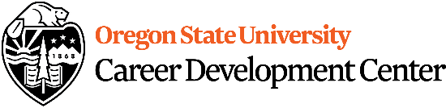
CAREER DEVELOPMENT CENTER
A110 KERR ADMINSTRATION BUILDING
541.737.4085 career@oregonstate.edu

