VMock Classroom Assignment | Beyond OSU: Artifact

Assignment Overview:
Your resume is your calling card in the world of work. In this assignment, students will upload their current resume to VMock, receive scores and feedback, apply a template, use the “Smart Editor” to edit their resume, and retest their resume for score improvements. Students are also able to conduct a peer or professional review at the end of the process.

Learning Outcomes:
- Develop a professional resume.
- Implement feedback offered by the VMock software.

Beyond OSU:
This assignment falls under the Beyond OSU I (Prepare) learning outcome #2: Apply life-long career development through the creation of career artifacts.

NACE Competencies:
Skills developed completing this assignment: Professionalism, Communication, Critical Thinking, Technology, Career & Self-Development
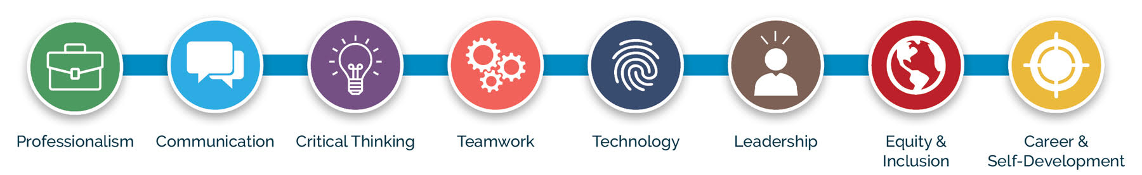

Instructor details:

Step 1:
As the course instructor, go to VMock and follow log-in instructions using the Career Services tab. Please visit the
Career Development Center website and complete the Support Request Form if you discover you do not have
access.

Step 2:
Before implementing the assignment, have students activate their account using their ONID email address on the
VMock Student/Alumni tab. Students need to have their VMock activated before you can find and tag them for
potential review (see review section options in the instructor notes on the last page of this assignment). You have
options in how you facilitate and grade this assignment.

Step 3:
Follow student instructions on next page: This assignment can be done in class, as an out-of-class
assignment or asynchronously over a set window of time (or a mix of methods). We recommend that
instructors upload a test resume and follow the student instructions to better understand how the
templates and SMART Editor function in VMock. This is a quick and intuitive process, and it will help you
decide how to grade and administer the assignment. Give it a try!

Option:
This assignment has an optional peer review* for students to provide feedback to one another. Those instructions
can be found on the last page of this document. Students can request person-to-person feedback through VMock
using an email address or download and save their resume (as a PDF or Word document) to email or share for in-
class review.
*IMPORTANT: We recommend that if you add a peer review, have students remove personal information from their resume before sharing with other students or reviewers they don't know. Students should leave their names, but remove address, phone number, personal email address, and any social media they would prefer to keep private. Students might also want to remove these items if only the instructor is viewing, depending on their comfort level. We recommend letting students know that for a professional resume they'll want to use contact information, but for this course assignment they have personal choice.

Student Instructions:

Step 1:
Go to VMock and follow log-in instructions under the Student/Alumni tab. Make sure you login using your
university ONID email address. Your free access is only available via your ONID.

Step 2:
Click “Upload Resume” and select a PDF version of your resume file. Once uploaded, the review process
is initiated. (Note: If you don’t have a resume, don’t worry! You can click the “create new resume”
button on the right side of the dashboard). This will allow you to choose a template and start building
a resume to be reviewed in VMock.
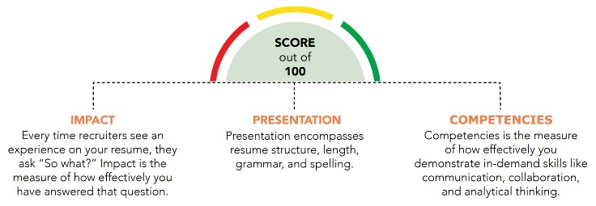
VMock will automatically provide overall scoring on a scale of 0-100 with feedback in three distinct areas (Impact, Presentation and Competencies). These scores will appear in three color zones (RED, YELLOW or GREEN).
Keep in mind: Your initial score may be very low or in the RED.
Don’t worry about your first score, sub scores or zones as VMock will guide you through each section. The goal of this assignment is to improve your overall score and sub scores to build a more effective resume.
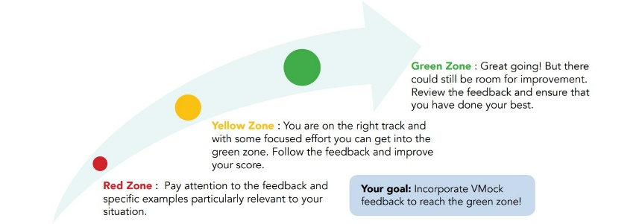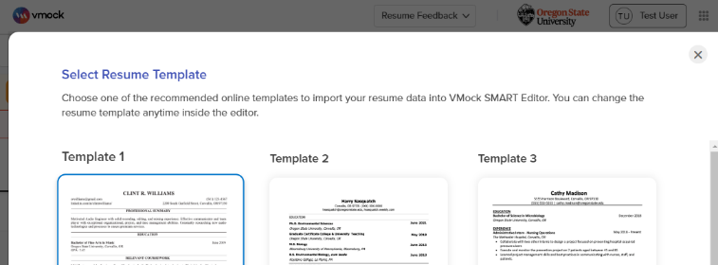

Step 3:
Select a resume template from the SMART Editor in VMock and apply it to your resume. You can
toggle between templates to see which works best for you. Keep in mind that the SMART Editor will
not function without a template applied.

Step 4:
Review Feedback provided through the SMART editor and begin incorporating the changes directly in
VMock. Please note that you can change the templates anytime using the waffle template icon in
the SMART Editor.
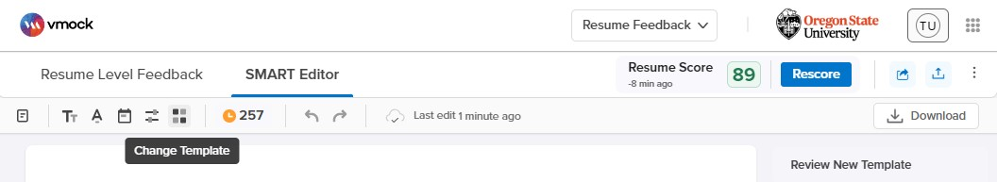

Step 5:
Once you have reviewed all sections of your resume comprehensively and addressed bullets and content for
improvement, rescore your resume to verify your improvements. While you are in the SMART Editor, you will see
live improvements via color indicators (red/yellow/green).

NOTE: As this rescore will count towards your 10 uploads, please make sure to double-check all areas of your resume in the SMART Editor prior to the rescore. You can use more than one rescore, but for this assignment only 2 total uploads should be required.

Step 6:
Optional: Your instructor might also assign a peer review*. You can request person-to-person feedback through
VMock using an email address or download and save your resume (as a PDF or Word document) to email or print
for future review, editing and usage. Follow the easy steps below to send your resume to a peer for feedback.
Follow your instructor’s advice on how and when to use this feature for the assignment. It’s possible they also
might assign peer review via Canvas instead.
*IMPORTANT: We recommend that you remove all personal information from your resume before sharing with other students or reviewers you don't know. You should leave your name, but remove address, phone number, personal email address, and any social media you would prefer to keep private. You might also feel more comfortable removing these items before submitting your resume to the instructor.
Requesting Feedback: Log into VMock using your ONID.
- After you have edited and reached a point where you are happy with your resume, select the “Share for Network Feedback” option. A box will pop up prompting you to enter your reviewer’s email address.
- If your resume is tailored to a specific job posting or role, enter that under the “Targeted Job Title”. If you do not have a specific role in mind, enter “N/A”. You can also add additional notes or requests for your reviewer in the following, optional section.
- Once you have entered the reviewer’s email address, click “Share.”
Your reviewer will receive an email with your request for feedback. They can either choose to provide feedback directly in the VMock platform or separately. If they opt to use the VMock system, you will receive an email notification that your feedback is available.

Student Worksheet: (write your answers in the space provided next to the questions)

List your initial scores after first upload:
Initial Total Score:
Impact/Presentation/Competencies sub scores (list 3 numbers):
List your scores after using the SMART Editor:
Revised Total Score:
Impact/Presentation/Competencies sub scores (list 3 numbers):
Reflection Feedback:
After using Vmock, what were some of the features you felt were most helpful? (list answers below)

What are some of the drawbacks to using Vmock for your resume? (list answers below)

Notes for Instructors:

Please adjust this assignment to fit your schedule, point system and course outcomes. While this VMock assignment is designed intentionally in this format and length, we know that career development in the classroom is not a one-size-fits-all process. Be mindful of your audience, and their specific career needs and understanding of resumes when implementing this assignment. Consider any specific industry elements you’d like to incorporate into this assignment (specific resume tips, peer or professional review) to make it more engaging and useful for your students.

Suggestions for this assignment:

Length:
This assignment has three main components to consider but has an optional person-to-person review as a fourth component. 1) Base score (VMock upload #1); 2) Use of SMART Editor; 3) Revised/Improved score (VMock upload #2); and 4) optional outside review. This assignment allows for a review by an individual that is not the student or instructor, but it can also be taught without the outside review. We suggest building a peer review or connecting with alumni from your college for a higher level of engagement and feedback. We’ve included some tips for creating peer reviews.

Faculty Review of Resumes:

Option 1:
Compile your class: This process involves tagging your class(es) in VMock after your students have logged in and completed the assignment. Students must log into VMock using their ONID emails before tagging can occur. The benefit of this option is that you can quickly view pre- and post-scores and resumes directly in VMock, making the grading process more efficient. Please note that this option requires additional steps. Be sure to complete the Career Development Center’s Support Request Form prior to your implementation if you need assistance. This element takes time, so plan accordingly.

Option 2:
Students manually upload assignment in Canvas: With this process, students fill in the worksheet above, save this document, download their final resume as a PDF file from VMock, and upload both items to canvas for the assignment.

Option 3:
In class review session: This process has students submitting their final resume for a peer review or class review based on your intended outcomes. This could be combined with a resume upload to Canvas for assignment completion.

Reminder:
Have students remove personal information from their resume before sharing with other students or reviewers they don’t know. Students should leave their names, but remove address, phone number, personal email address, and any social media they would prefer to keep private. Students might also want to remove these items if only the instructor is viewing, depending on their comfort level.

Notes for Instructors (cont.)

Assessment & Submission:
Please assess this assignment appropriately for your class. We recommend a rubric with the goal of an improved VMock score (in the yellow zone or higher) through submitting a base/initial score, use of the templates and SMART Editor for improvements and a revised score. We’ve also included an optional peer review in the sample rubric below, but feel free to remove it. The scores will all appear on your VMock dashboard (if you chose option 1). You can also add a feedback section (Step 6) where students ask for feedback from a classmate through VMock (via email) or conduct an in-class review session. Depending on your grading philosophy, students could also receive points if they submit an initial score, an updated score and a final resume via Canvas (all components viewable in Vmock itself as well).
Sample Scoring Rubric | Weight | Earned
Initial Upload and Score | 10%
Applied Template/SMART Editor | 30%
Improved Secondary Score | 30%
Feedback or Peer Review | 30%
Total Score | 100%

Additional Resources:
Please consider using the robust online resources the Career Development Center offers you and your students. For more information on using the Career Development Center's tools, events and workshops in your classroom, please visit our website.

Designed and created by the:
Career Development Center
career@oregonstate.edu

