VMOCK USER GUIDE
SMART RESUME and SMART Editor
VMock SMART Editor
VMock Resume Optimizer - Powered by SMART Editor
VMock Mock Interview
VMock SMART Interview
VMock Elevator Pitch

SMART RESUME and SMART Editor

How-to Guide

GETTING STARTED
- Go to www.vmock.com/oregonstate
- Log in using your University ID
- Click on “Resume” in the top navigation panel and click on “Resume Feedback.”
- Upload your Resume in PDF format or create one from scratch for the assessment

UNDERSTANDING VMOCK SCORING AND FEEDBACK

What is VMock Resume Score?
Provided on a scale of 1-100, VMock Resume score is computed based on 3 core modules. It appears automatically in your Student Dashboard after completion of the review process.

What does the score mean for you?
It indicates how well your resume presents your profile to recruiters and can belong to either Red, Yellow or Green zone.

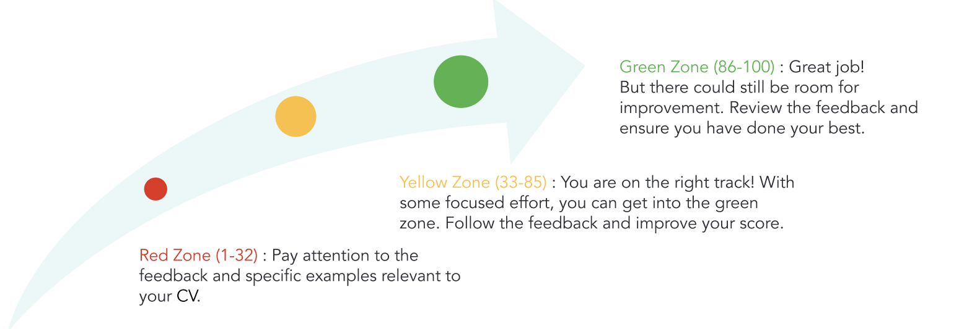
Chart details: The scoring zones for Vmock are Red (1-32), which shows that you need improvement; Yellow (33-85), which shows that you are on the right track but can still improve your score; and Green (86-100) which shows that you’ve done a great job and need only small improvements.

VMOCK RESUME LEVEL FEEDBACK
Resume Level Feedback has three main modules: impact, presentation and competencies.
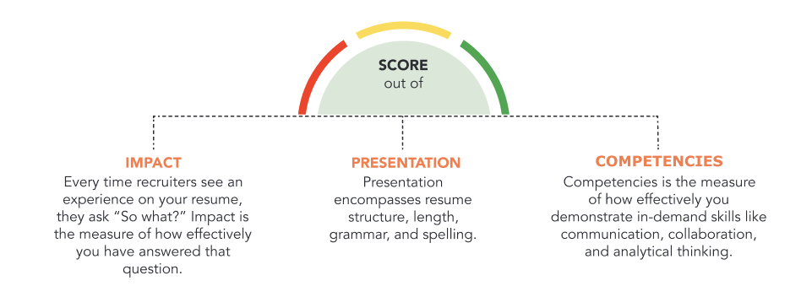
Chart details: The “Impact” feedback module describes how your resume will impact recruiters. Every time recruiters see an experience on your resume, they ask, “So what?” Impact measures how effectively you have answered that question. The “Presentation” feedback module encompasses resume structure, length, grammar and spelling. The “Competencies” module measure how effectively you demonstrate in-demand skills like communication, collaboration and analytical thinking.
- You may navigate between each module by clicking on its name, below your resume score.
- Each main module is comprised of core elements. Scroll down and click through each core element to view corresponding feedback highlighted in your resume.

UPDATE YOUR RESUME
When you are finished reviewing VMock’s detailed feedback, it’s time to revise your resume by incorporating the feedback and customized suggestions.
Once you’ve completed your updates, re-upload your newly edited resume to view your increased score and suggestions for further improvement until you reach the green zone!

VMock SMART Editor
VMock includes an advanced SMART Editor to help you achieve all-star profile strength. Machine learning engines scan your resume to offer instant and targeted sample suggestions for each bullet. Secure 24/7, real-time guidance from the platform can make your resume stand out and maximize your job-search outcomes!

LEVERAGE THESE KEY FEATURES:
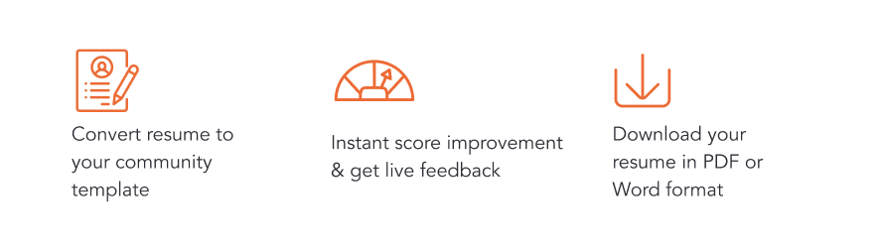
Chart details: Key features in VMock are resume conversion (you can convert your resume to a community template); score improvement (you can get live feedback and instant score improvement); and resume downloads (you can download your resume in PDF or Word format).

CREATING NEW RESUME:
- Click on 'Resume' on the top navigation panel of the user dashboard. Select SMART Editor from the dashboard.
- If you don’t have a resume yet, you can simply add your information using our template which will pop up right when you open SMART Editor.
- Start adding content and follow the step-by-step guidance wherein the system will provide real time feedback. Once you have added sufficient content, you can score your resume and see detailed feedback.

IMPROVING AN EXISTING RESUME:
- Upload your existing resume in PDF format to get started.
- VMock SMART Editor will convert your resume into the community template.
- Follow the step by step SMART Editor guidance across the product.
- You can download your resume in PDF and Docx format.
- Once you have made all the changes, you can re-score your resume to get an updated score and detailed feedback.

VMock Resume Optimizer - Powered by SMART Editor

How-To Guide

Resume optimization is a critical step before you apply for a job. But how do you know what makes a resume ready? How can you get the right keywords in your resume to go through the ATS? The Resume Optimizer module can help!
Resume Optimizer enables you to create a recruiter-ready resume for a job description. It instantly scans and provides an analysis of your resume - identifying missing keywords, soft skills, and all prerequisites.

OPTIMIZER FEATURES

Match Score: Get an accurate match score of your resume against the job description.

Keywords Analysis & Targeted Recommendations: Equip you with functional and general keywords and their count to improve the effectiveness of your resume. Also, it provides bullet-level recommendations and targeted sample phrases in accordance with the job description.
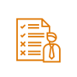

Skill Gap Analysis & Sample Bullets Recommendation: Run a soft skill gap analysis and identify the transferable skills that showcase your readiness for the specific job. It also helps you in improving your resume by suggesting keywords and sample bullets for each skill.
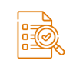
Requirement Analysis: Showcase your academic experience and technical know-how on tools and certification requirements that are needed for the job.
ATS Formatting: Obtain content and presentation check feedback on the basis of ATS requirements.

GETTING STARTED
Follow these steps to access Resume Optimization:
- Go to www.vmock.com/oregonstate
- Once registered, the platform will redirect you to the user dashboard
- Click on Resume Optimization from the right navigation menu under “My Activities.”
- Upload a job description and select a resume for optimization.
- Get a match score and feedback summary on keywords, skills, requirements, and ATS formatting.
- Edit your resume based on optimization feedback and recommendations with SMART Editor.
- After making changes, re-evaluate your resume to get an updated optimization score (Note: you only get 20 scans in an academic year).
- Download your optimized resume in a PDF or Word format.
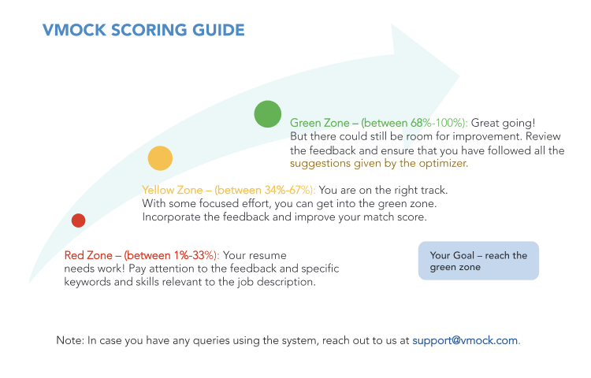
Chart details: The VMock Scoring Guide has three zones. The Red Zone (1-33%) shows that your resume still needs work. The Yellow Zone (34-67%) shows that you are on the right track but still need improvement. The Green Zone (68-100%) shows that you have done a great job but could still make some small improvements.

VMock Mock Interview

How–To Guide

VMock Mock Interview platform, targeted toward the desired career, leverages state-of-the-art techniques in Computer Vision, Natural language processing, and Machine Learning to help users unlock their full potential in interviews. The platform offers real-time guidance which is customized to each user’s career aspirations. It aims to deliver pointed feedback on pertinent interview parameters so as to allow maximum conversion of an interview attempt. Users also gain actionable guidance in the form of samples such as tutorial videos and articles for each feedback module.

KEY BENEFITS
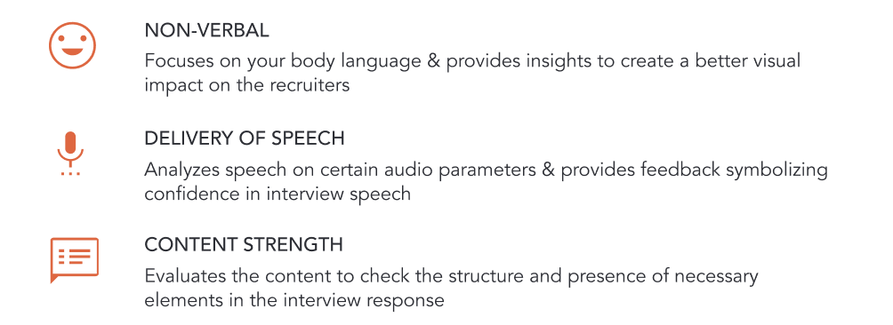
Chart details: VMock Mock Interview platform provides benefits in three areas. Non-Verbal focuses on your body language and provides insights to create a better visual impact on recruiters. Delivery of Speech analyses your speech on certain audio parameters and provides feedback symbolizing confidence in interview speech. Content Strength, evaluates the content of your words, checking the structure and presence of necessary elements in your interview response.

SALIENT FEATURES
- VMock Mock Interview platform provides built-in mock interview sets for 100+ career tracks for students to practice.
- Students can create their own custom mock interview from the question library section on the platform or ask their peers and coaches to create one.
- Students can attempt assessments floated by career coaches and receive AI feedback. On the other hand, career coaches can verify the submissions and add their own feedback to the interviews.

GET STARTED
- Go to www.www.vmock.com/oregonstate and select Interviews from the top navigation menu and click on “Mock Interview.”
- Select up to 3 career preferences from the list of careers and get started.
- You would get mock Interviews for different career tracks associated with the chosen preferences with various difficulty levels.
- You can also upload your resume to get mock interviews as per system recommendations as per your resume.
- You can create a mock interview by yourself or ask your peers and coaches to create an interview for you. You can also attempt mock interviews shared with you in the form of assessments by your career centre.
- Understand the steps to overall improvements in the summary section to take your interview to the next level.
- Go through the "know more" and "next steps" in detailed feedback section. Incorporate the overall feedback in your next interview. You can also share your video to your career coach and peers for the Network Feedback.

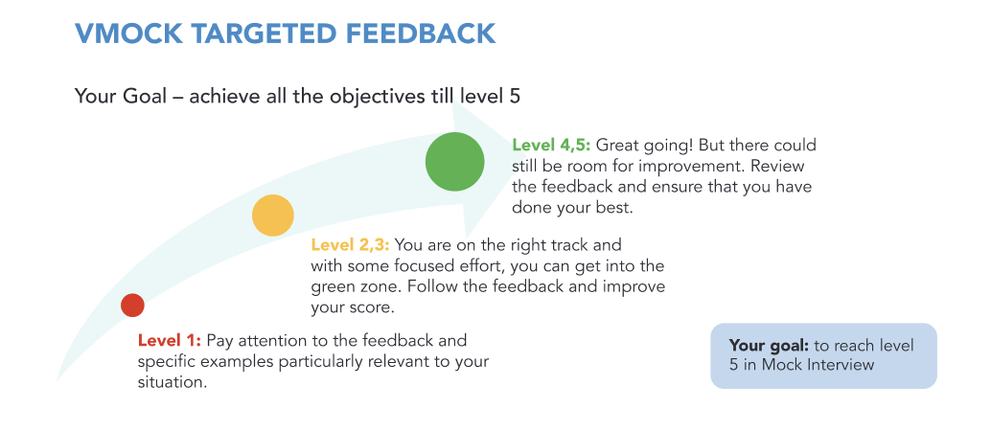
Chart details: Vmock targeted interview feedback scores your responses on a 5-level system. Level 1: you should pay attention to feedback to improve. Level 2 or 3: You are on the right track, but have room for improvement. Level 4 or 5: You’ve done great, but there is still some small room for improvement.

VMock SMART Interview

How–To Guide

VMock SMART Interview platform, targeted toward the desired career, leverages state-of-the-art techniques in Computer Vision, Natural language processing, and Machine Learning to help you unlock your full potential in interviews. With VMock SMART Interview, you can upload a set of target job descriptions and resume to auto-populate a personalized mock interview to get 360-degree feedback on your verbal and non-verbal cues, etc. You can also edit, replace or delete questions based on your needs and preparation level.

SALIENT FEATURES
- Provides tailored interviews based on Resume and Job Description.
- Prepare for real-life interviews with a dynamic question set.
- Get real-time feedback on your verbal, non-verbal, and speech parameters.
- Practice personal, job fit, experience and knowledge-based questions.
- Delete or add questions as you see fit with the flexibility of changing the time required to answer.

GET STARTED
- Go to www.vmock.com/oregonstate and select “Interview” from the top navigation menu and click on “SMART Interview.”
- Select “Generate Interviews” from the left hand side of the dashboard and upload a pair of job description and resume in the next step.
- Based on the job description and the resume uploaded, the system will generate a set of interview questions.
- You have the option to add or delete questions as you see fit. You can even change the time required to answer each question.
- Once you are satisfied, click on “Start Interview” at the bottom right. Go through the instructions carefully to “Start Calibration.”
- Record your answers as the questions pop up and click on “End Interview” once completed.
- Incorporate the overall feedback in your next interview. You can also share your video with your career coach and peers for the Network Feedback.

VMock Elevator Pitch

How-To Guide
VMock Elevator Pitch analyzes your interview holistically and instantly reveals crucial hidden information in your body language, enunciation and content. It also allows you to watch your interview with time-aligned feedback, making it much easier to understand feedback and act on it.

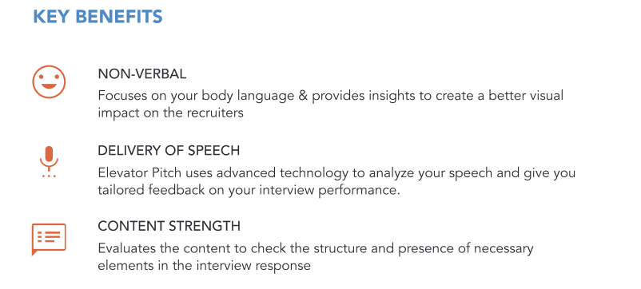
Chart details: VMock Elevator Pitch platform provides benefits in three areas. Non-Verbal focuses on your body language and provides insights to create a better visual impact on recruiters. Delivery of Speech analyses your speech on certain audio parameters and provides feedback symbolizing confidence in interview speech. Content Strength, evaluates the content of your words, checking the structure and presence of necessary elements in your interview response.

SALIENT FEATURES
- Get instant feedback on your interview based on your body language, diction and content, which is holistic and not subjective.
- Watch your interview and get time aligned feedback. It is easier to improve if you can watch and hear your interview performance along with the feedback.
- No interview scheduling hassles, no geographic or time constraints. Practice your interview whenever you want, wherever you want.

GETTING STARTED
- Go to www.vmock.com/oregonstate. Once registered, the platform will redirect you to the user dashboard.
- Go to Interviews by navigating to the tabs at the top of the dashboard and select Elevator Pitch from the drop down.
- To begin your elevator pitch, click on ‘Start Recording’
- Follow the calibration process step by step, as shown on your screen. Once this process is complete, you can begin the ‘Please tell me about yourself’ question.
- You will also see a two-minute timer on the right hand side of your screen. Once you’re done with your pitch, click on ‘Stop Recording’.
- The system will take a few minutes to process your video. Please do not close this tab before your interview gets uploaded. Your feedback will be ready in a minute. Elevator Pitch Feedback is available based on three major sections, each focusing on key interview aspects.
- Be sure to click on ‘View Detailed’ feedback to understand and improve your holistic interview performance.
- Incorporate the overall feedback in your next interview. You can also share your video to your career coach and peers for the Network Feedback.
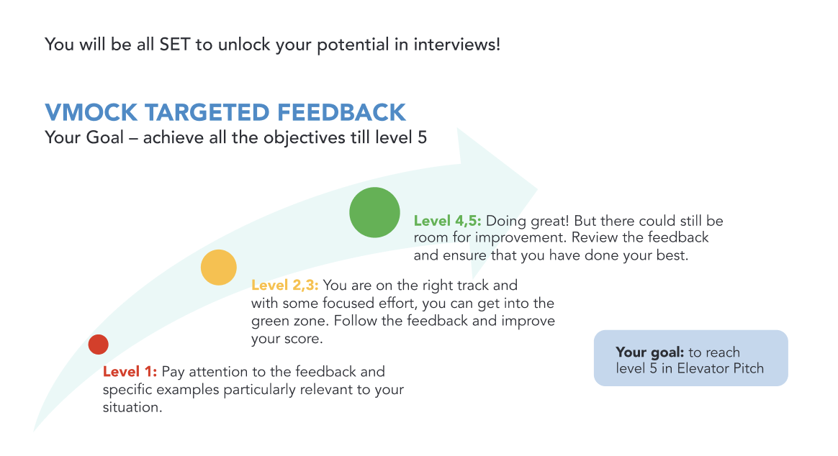
Chart details: Vmock targeted interview feedback scores your responses on a 5-level system. Level 1: you should pay attention to feedback to improve. Level 2 or 3: You are on the right track, but have room for improvement. Level 4 or 5: You’ve done great, but there is still some small room for improvement.

